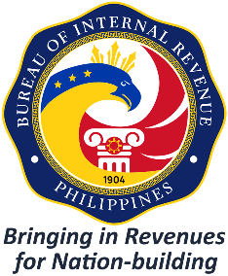

**REPUBLIC OF THE PHILIPPINES**

DEPARTMENT OF FINANCE

# BUREAU OF INTERNAL REVENUE

**Accounts Receivable Monitoring Division**

**ANNEX “L”**

*Address*

Date

**Name of the Requesting Person**

Position/Designation

Office Address

Sir/Madam:

This refers to your letter dated (Date of Request Letter) which was received by this Office on (Date of receipt by the Office) requesting confirmation on the authenticity of Tax Clearance *for Final Settlement of Government Contracts* with **(Tax Clearance Control Number) ,** allegedly issued by this Office to **(Name of Taxpayer)** with TIN (14 digits TIN) (“Annex A”).

Please be informed that, upon verification by this Office, the attached copy of the Tax Clearance is **VALID/SPURIOUS/NOT AUTHENTIC** and duly issued/has not been duly issued by this Office and the signature of the approving official thereof is apparently forged. It is further informed that duly approved Tax Clearances for Final Settlement of Government Contracts may be verified from the BIR Portal under its “Announcements”, “Tax Clearance” and Released Tax Clearance” screens.

For your information and guidance.

Very truly yours,

**Name of the Authorized Signatory**

Chief, Collection Division

RR No.___/LTD-Cebu/LTD-Davao/LTCED

Office Code